Introduction to WebService 2
Types of Web Services 2
Web Service Jargon 2
Web Services Description Language (WSDL) 2
Universal Description, Discovery & Integration (UDDI) 3
Simple Object Access Protocol (SOAP) 3
Service EndPoint Interface (SEI) 4
How Web Service work? 4
Writing a Web Service Client 5
Already created WebService URLs- 5
Test WSDL using SOAP UI 5
Generate Stub using wsimport 5
Using java.net.HttpURLConnection 5
Approaches to a Create a Web Service 5
Elements of WSDL 6
Create & Deploy a JAX-WS based web service 8
Bottom up Approach 8
Revisit generated WSDL 8
Top Down Approach 9
Test Services using SOUP UI 11

Introduction to WebService
Web services provide a standard means of interoperating between different software applications, running on a variety of platforms and/or frameworks.
A service available on Web is called as Web Service which will be consumable by any other products, understandable by an application / codebase. That’s why a Web application is not a WebService even it is available on web as a service.
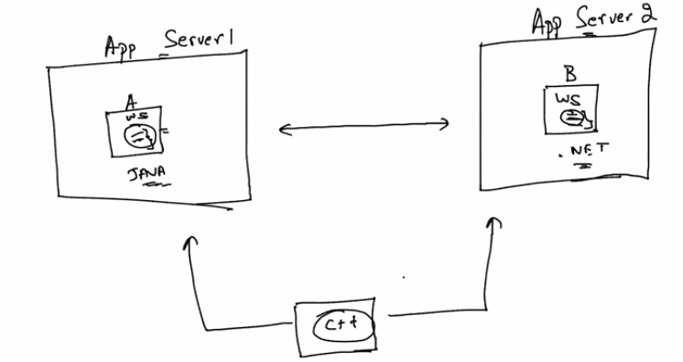

Types of Web Services
- SOAP based Web Service (based on JAX-WS specification)
- REST based Web Service (based on JAX-RS specification)

Web Service Jargon

Web Services Description Language (WSDL)
WSDL is the XML-based file that describes the web service. The web service request uses this file to bind to the service. It is an interface / contract of a Web Service.
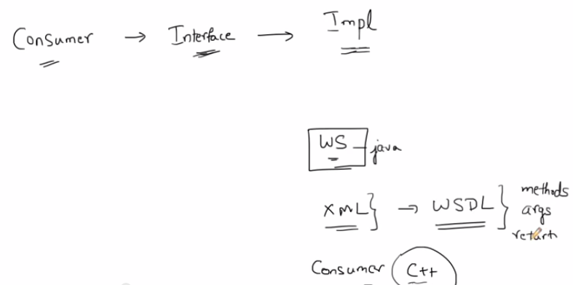

Universal Description, Discovery & Integration (UDDI)
UDDI is a directory service where businesses can register and search for Web services. It’s like yellow pages of web services.

For Example-
If the industry published an UDDI standard for flight rate checking and reservation, airlines could register their services into an UDDI directory. Travel agencies could then search the UDDI directory to find the airline's reservation interface. When the interface is found, the travel agency can communicate with the service immediately because it uses a well-defined reservation interface.

Simple Object Access Protocol (SOAP)
SOAP is the XML-based protocol that the web service request uses to invoke the service. SOAP is an XML-based protocol to let applications exchange information over HTTP.
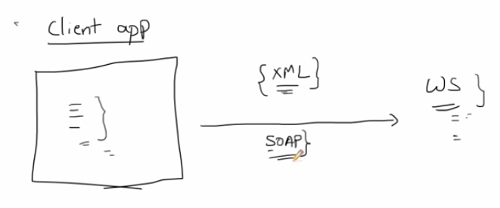

Why SOAP?
It is important for application development to allow Internet communication between programs.
Today's applications communicate using Remote Procedure Calls (RPC) between objects like DCOM and CORBA, but HTTP was not designed for this. RPC represents a compatibility and security problem; firewalls and proxy servers will normally block this kind of traffic.
A better way to communicate between applications is over HTTP, because HTTP is supported by all Internet browsers and servers. SOAP was created to accomplish this.
SOAP provides a way to communicate between applications running on different operating systems, with different technologies and programming languages.

SOAP Building Blocks
A SOAP message is an ordinary XML document containing the following elements:
- An Envelope element that identifies the XML document as a SOAP message
- A Header element that contains header information
- A Body element that contains call and response information
- A Fault element containing errors and status information
All the elements above are declared in the default namespace for the SOAP envelope:
http://www.w3.org/2001/12/soap-envelope
And the default namespace for SOAP encoding and data types is:
http://www.w3.org/2001/12/soap-encoding

Skeleton SOAP Message
<?xml version="1.0"?>
<soap:Envelope
xmlns:soap="http://www.w3.org/2001/12/soap-envelope"
soap:encodingStyle="http://www.w3.org/2001/12/soap-encoding">
<soap:Header>
...
</soap:Header>
<soap:Body>
...
<soap:Fault>
...
</soap:Fault>
</soap:Body>
</soap:Envelope>

Service EndPoint Interface (SEI)
The service endpoint interface (SEI) is a Java interface class that defines the methods to be exposed as a Web service. It access a web service interface & responsible to translate Java Object (or any other platform specific object) to SOAP messages.

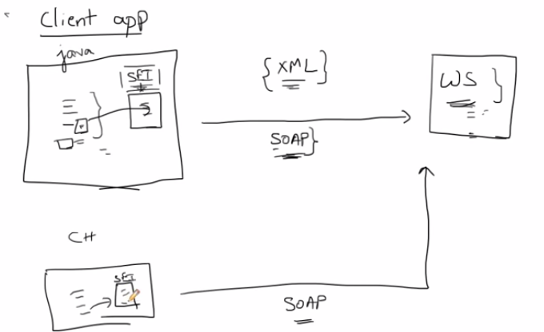

How Web Service work?
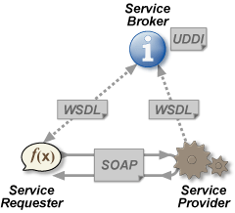
Web services platform elements:
- SOAP (Simple Object Access Protocol)
- UDDI (Universal Description, Discovery and Integration)
WSDL (Web Services Description Language)

The basic Web services platform is XML + HTTP. XML provides a language which can be used between different platforms and programming languages and still express complex messages and functions. The HTTP protocol is the most used Internet protocol.

Writing a Web Service Client

Already created WebService URLs-
http://www.w3schools.com/xml/tempconvert.asmx
http://www.webservicex.net/New/Home/ServiceDetail/17
http://www.webservicex.net/ws/WSDetails.aspx?WSID=60&CATID=4

Test WSDL using SOAP UI
SOAP UI is a standard & very popular tool to test web service. We can generate a mock web service using this tool. Download it from http://www.soapui.org/downloads/older-versions.html

Generate Stub using wsimport
Use a wsimport tool (bundle inside JDK 1.6)
Usage: wsimport [options] <WSDL_URI> => It generates .class files (i.e. stub) using WSDL file.
-d <directory> specify where to place generated output files
-keep keep generated files
-s <directory> specify where to place generated source files

Open command prompt & goto root directory of project (i.e. jaxws) & execute below command to generate stub for a WSDL.
- wsimport -keep -s src\main\java -d target\classes http://www.webservicex.net/geoipservice.asmx?WSDL
- It generate .java files inside src\main\java & .classes inside target\classes
- Goto package “com.gps.jaxws” & create a Java class “IPLocationFinder.java”

Using java.net.HttpURLConnection
Capture SOAP request using SOAP UI tool & add parameter.
Example - com.gps.jaxws. SOAPServiceClient.java & com.gps.jaxws.ResponseInfo.java

Approaches to a Create a Web Service
There are 2 approaches to create a web service:
1) Top-Down / Contract First: WSDL to Java
Step 1: Create the WSDL and supporting Schema
Step 2: Generate the service from the WSDL

Advantage-
- It’s independent of programming language
- It is more descriptive than a generated WSDL file, you’re able to apply more restrictions
and rules here that you otherwise needed to implement in some method in your
concrete programming language

2) Bottom-Up / Service First: Java to WSDL
Step 1: Create Implementation class first & annotate with @WebService
Step 2: Start application & Engine generate WSDL against Implementation class

Elements of WSDL
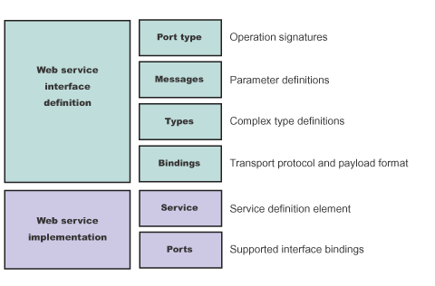
A WSDL document defines services as collections of network endpoints, or ports. In WSDL, the abstract definitions of endpoints and messages are separated from their concrete network deployment or data format bindings. This separation supports the reuse of abstract definitions: messages, which are abstract descriptions of exchanged data, and port types, which are abstract collections of operations. The concrete protocol and data format specifications for a particular port type constitute a reusable binding. A port is defined by associating a network address with a reusable binding, and a collection of ports defines a service. Therefore, a WSDL document is composed of several elements.
A WSDL file describes a web service with the following elements:
- portType
The description of the operations and associated messages. The portType element defines abstract operations.
<portType name="EightBall">
<operation name="getAnswer">
<input message="ebs:IngetAnswerRequest"/>
<output message="ebs:OutgetAnswerResponse"/>
</operation>
</portType>
- message
The description of input and output parameters and return values.
<message name="IngetAnswerRequest">
<part name="meth1_inType" type="ebs:questionType"/>
</message>
<message name="OutgetAnswerResponse">
<part name="meth1_outType" type="ebs:answerType"/>
</message>
- types
The schema for describing XML types used in the messages.
<types>
<xsd:schema targetNamespace="...">
<xsd:complexType name="questionType">
<xsd:element name="question" type="string"/>
</xsd:complexType>
<xsd:complexType name="answerType">
...
</types>
- binding
The bindings describe the protocol that is used to access a portType, as well as the data formats for the messages that are
defined by a particular portType element. Binding states that how the service accepts request & give response?
<binding name="EightBallBinding" type="ebs:EightBall">
<soap:binding style="rpc" transport="schemas.xmlsoap.org/soap/http">
<operation name="ebs:getAnswer">
<soap:operation soapAction="urn:EightBall"/>
<input>
<soap:body namespace="urn:EightBall" ... />
...
- service
The services and ports define the location of the Web service. The service contains the web service name and a list of
ports.
- port
The ports contain the location of the web service and the binding used for service access.
<service name="EightBall">
<port binding="ebs:EightBallBinding" name="EightBallPort">
<soap:address location="http://localhost:8080/axis/EightBall"/>
</port>
</service>
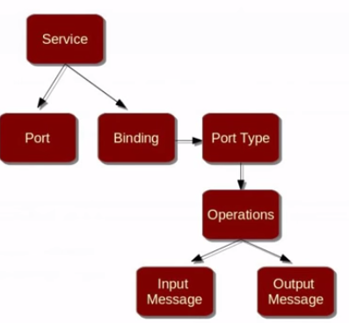
The binding element has two attributes - name and type.
The name attribute (you can use any name you want) defines the name of the binding, and the type attribute points to the port for the binding, in this case the "glossaryTerms" port.
The soap:binding element has two attributes - style and transport.
The style attribute can be "rpc" or "document". In this case we use document. The transport attribute defines the SOAP protocol to use. In this case we use HTTP.
The operation element defines each operation that the port exposes.
For each operation the corresponding SOAP action has to be defined. You must also specify how the input and output are encoded. In this case we use "literal".

Create & Deploy a JAX-WS based web service

Bottom up Approach

- Configure tomcat with Maven inside pom.xml

- Add dependency to deploy WebService using Maven
<dependency>
<groupId>com.sun.xml.ws</groupId>
<artifactId>jaxws-rt</artifactId>
<version>2.2.10</version>
</dependency>

- Execute mvn clean install –U & mvn eclipse:eclipse and Refresh eclipse Workspace

- Change packaging from Jar to war inside pom.xml

- Create Service Endpoint Interface using Interface
Example - com.gps.jaxws.HelloWorld.java

- Create Service Implementation Bean which is a implementation class for above interface
Example - com.gps.jaxws. HelloWorldImpl.java

- Create a web service deployment descriptor, which is also known as JAX-WS RI deployment descriptor & put it to src/main/webapp/WEB-INF folder.
Example - src/main/webapp/WEB-INF/sun-jaxws.xml

- Create a standard web.xml file in the same directory src/main/webapp/WEB-INF folder
Example - src/main/webapp/WEB-INF/web.xml

- mvn clean install

- Start tomcat & execute mvn tomcat7:deploy

- Open URL - http://localhost:8080/jaxws/Hellows

Revisit generated WSDL
- portType
The description of the operations and associated messages. The portType element defines abstract operations.
<portType name="HelloWorld">
<operation name="getHelloWorldAsString">
<input wsam:Action=http://jaxws.gps.com/HelloWorld/getHelloWorldAsStringRequest
message="tns:getHelloWorldAsString"/>
<output wsam:Action="http://jaxws.gps.com/HelloWorld/getHelloWorldAsStringRespons
e" message="tns:getHelloWorldAsStringResponse"/>
</operation>
</portType>
- message
The description of input and output parameters and return values.
<message name="getHelloWorldAsString">
<part name="arg0" type="xsd:string"/>
</message>
<message name="getHelloWorldAsStringResponse">
part name="return" type="xsd:string"/>
</message>
- types
The schema for describing XML types used in the messages.
- binding
The bindings describe the protocol that is used to access a portType, as well as the data formats for the messages that are
defined by a particular portType element. Binding states that how the service accepts request & give response?
<binding name="HelloWorldImplPortBinding" type="tns:HelloWorld">
<soap:binding transport="http://schemas.xmlsoap.org/soap/http" style="rpc"/>
<operation name="getHelloWorldAsString">
<soap:operation soapAction=""/>
<input>
<soap:body use="literal" namespace="http://jaxws.gps.com/"/>
</input>
<output>
<soap:body use="literal" namespace="http://jaxws.gps.com/"/>
</output>
</operation>
</binding>
- service
The services and ports define the location of the Web service. The service contains the web service name and a list of
ports.
<service name="HelloWorldImplService">
<port name="HelloWorldImplPort" binding="tns:HelloWorldImplPortBinding">
<soap:address location="http://localhost:8080/jaxws/Hellows"/>
</port>
</service>

- port
The ports contain the location of the web service and the binding used for service access.
<port name="HelloWorldImplPort" binding="tns:HelloWorldImplPortBinding">
<soap:address location="http://localhost:8080/jaxws/Hellows"/>
</port>

Top Down Approach

- Create a XML Schema
Example – src/main/resources/schema/bookService.xsd

- Create a WSDL file
Example – src/main/resources/wsdl/bookService.wsdl

- Create Stub classes using JAX-WS & Maven
<dependency>
<groupId>org.codehaus.mojo</groupId>
<artifactId>jaxws-maven-plugin</artifactId>
<version>1.12</version>
</dependency>
<plugin>
<groupId>org.codehaus.mojo</groupId>
<artifactId>jaxws-maven-plugin</artifactId>
<version>1.12</version>
<configuration>
<wsdlDirectory>${basedir}/src/main/resources/wsdl</wsdlDirectory>
<packageName>com.gps.jaxws</packageName>
<keep>true</keep>
<sourceDestDir>${basedir}/src/main/java</sourceDestDir>
</configuration>
<executions>
<execution>
<goals>
<goal>wsimport</goal>
</goals>
</execution>
</executions>
</plugin>

- Generate the sources from WSDL using
mvn clean generate-sources

- Write Server Implementation Service
Example - com.gps.jaxws. BookServicePortImpl.java

- Create Server Instance
Entry inside web.xml & inside sun-jaxws.xml

- mvn clean install -U

- Start tomcat & execute mvn tomcat7:deploy

- Open URL - http://localhost:8080/jaxws/Hellows & http://localhost:8080/jaxws/BookWs

Test Services using SOUP UI
